
Business / Technical Brief

PEOPLESOFT TO UNIFIER – PURCHASE ORDERS
INTEGRATIONS DESIGN SPECIFICATION DOCUMENT
Prepared For: Northwestern Memorial Healthcare

  - Author: Anu Samantha
July 2025, Version 1.0
Copyright © 2026, Oracle and/or its affiliates
Confidential – Oracle Restricted
Documnet Control

Change Record
Date | Author | Version | Change Reference
06/30/2025 | Anu Samantha | 1.0 | Initial Draft

Reviewers
Full Name | Title
Farkas-Loewes, Monika | NM Business
VanZale, Steve | NM IT
Agrawal, Amit | NM IT
Singh, Vishnu Devanand | NM IT

Approvals:
Approver 1 | Farkas-Loewes, Monika
Approver 2 | Cloutier, Charlie

Tabel of Contents
1 Introduction 5
1.1 Purposes 5
1.2 Audience 5
1.3 References 5
2 Integrations Overview 6
3 Interface Design 7
3.1 I8050- PeopleSoft Purchase Order (“PO”) Data to Unifier PO Data 7
3.1.1 Properties of the Data Flow 7
3.1.2 Business Rules 8
3.1.3 Process Flow 8
3.1.4 Data Mapping 9
3.1.5 PIF Configuration 9
3.1.6 Error/Warning Handling 10
4 Assumptions 11
5 Appendix A: Acronyms 12
6 Appendix B: Issue Log 13

Table of Figures
Figure 1: Interface Details 6
Figure 2: High Level Interface Diagram 6
Figure 3: I8050 - PeopleSoft Data to Unifier-Create Purchase Order 7
Figure 36: Acronyms 12
Figure 37: Issue Log 13

Introduction
Integration is the process of moving data from one data source to another on a recurring basis. The intention is to keep the target data source synchronized with relevant data from another data source. One is typically the “system-of-record”. The integrations for Northwestern Memorial Healthcare will be developed and configured using Oracle Project Integration Framework (PIF) referred as PIF henceforth on this document.

Purposes
The purpose of this document is the following:
- Document Oracle’s technical design and process flow for the interface
- As a deliverable, allow Northwestern Memorial Healthcare to approve and sign-off on the technical design.
- Document and maintain changes to the design over time.
- Provide future administrators and developers technical documentation to support the interface.

Audience
This document is intended for the following audiences:
- Technical resources supporting infrastructure.
- Application administrators and developers
- Northwestern Memorial Healthcare and Oracle Project Managers
- Solution Architects
- Business

References
This design specification refers the following information sources:
- Meetings and discussions with Northwestern Memorial Healthcare and Oracle teams.
- Field mapping identified by Northwestern Memorial Healthcare and Oracle teams.
- Future Process model
- Oracle’s Solution Design documents

Integrations Overview
This document covers the design details for transferring financial data from PeopleSoft to Primavera Unifier using PIF. PIF leverages web services to interface with PeopleSoft and Primavera Unifier.
The interfaces will be scheduled to run within PIF, and it also provides transaction log to view status of the integration jobs and email notifications for reporting transaction details and failures.
The below table details interface that will be implemented within the scope of integrations from PeopleSoft to Unifier. The term “Inbound” and “Outbound” is with the context to Primavera Unifier.

ID | Interface Name | Interface  Type | Source  System | Target  System
I8050 | I8050 - PeopleSoft Data to Unifier-Create Purchase Order | Inbound | PeopleSoft | Unifier
Figure 1: Interface Details

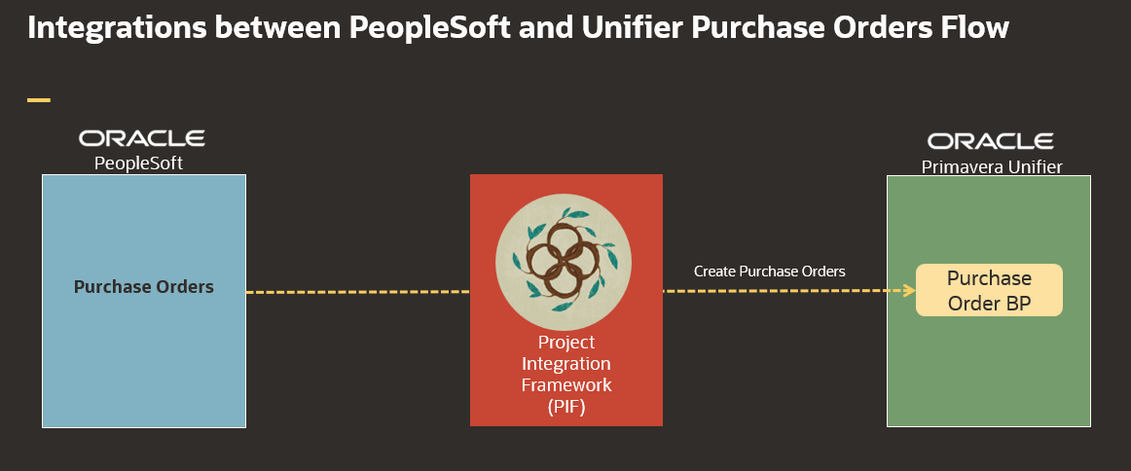
Figure 2: High Level Interface Diagram

Interface Design

I8050- PeopleSoft Data to Unifier – Create Purchase Order
This interface is used to create Purchase Orders from PeopleSoft View to Purchase Order BP records in Unifier.
1.Create Purchase Orders from PeopleSoft to Unifier

Properties of the Data Flow
Interface ID | I8050
Interface Name | I8050 - PeopleSoft Data to Unifier-Create Purchase Order
Source System Name | PeopleSoft
Source System Object Name(s) | NM_UA_PO_047
Target System Name | Unifier
Target System Object Name(s) | Purchase Order BP
Interface Type | Inbound
Interface Frequency | Nightly- Once
Approximate # of Rows | 30 Purchase Orders per day
Interface Mechanism | Unifier –Purchase Order BP  PeopleSoft – Views
Table Name Prefix | I8050
Figure 3: I8050 - PeopleSoft Data to Unifier-Create Purchase Order

Business Rules
Rule # | Rule Name | Rule Description
R-01 | Selection Criteria | POs will be brough in at Summary level (9 Categories)
R-02 | Selection Criteria | Only for 1100 CBS line level details should sent from PeopleSoft
R-03 | Title | Title will be REQ_name from PeopleSoft - Default will be Project ID+ Vendor ID + ReqID- Auto populated from Unifier (50 Char)
R-04 | Project Only | Create POs under each Project based on NM Project number
R-05 | PO Number | PO Number will be Unique

Process Flow
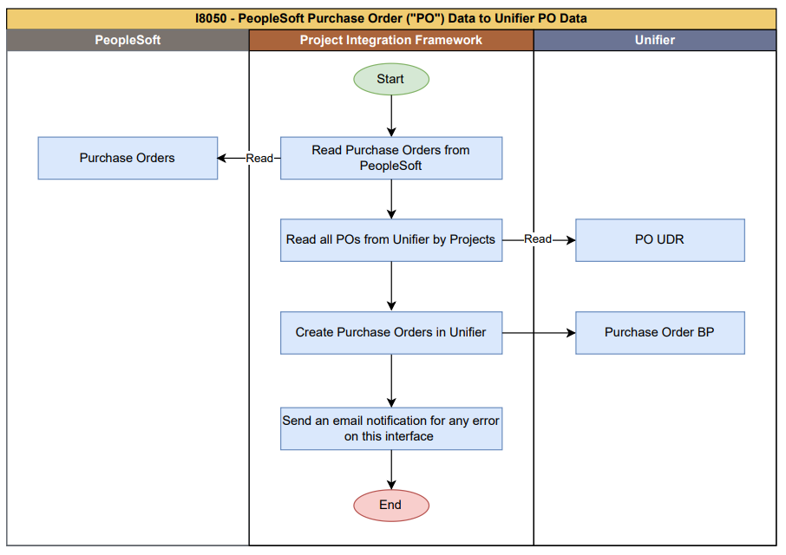
Figure 3: I8050 - PeopleSoft Data to Unifier-Create Purchase Order

- Clear data in PIF tables (if any) from last interface run.
- Read Purchase Orders from PeopleSoft View
- Read Existing Purchase Orders from Unifier through PO UDR
- Create Purchase Order records in Unifier project based on Business Rules.
- In case of any failure during Purchase Order BP record creation in Unifier then mark those records as failed in PIF tables
- Integration Last update field will be updated as SysDate – only updated by PIF Integration User (configured in Unifier Integration users)
- Populate Unifier PIF Integration status and Integration step field only in case of failures.
- Generate email error notifications if there are any errors while creating/updating Purchase Order data in Unifier.

Data Mapping
The below is the SharePoint link for data mapping for this interface.
Oracle-NM-PeopleSoft-Unifier-PurchaseOrder-Integration-Mapping.xlsx

PIF Configuration
Interface Name: I8050 - PeopleSoft Purchase Order ("PO") Data to Unifier PO Data

To be filled/corrected after completion of interface development.

Step No/ Intent | Step information | Business Rules / Comments
Step #: 10  Step Name: Clear staging tables | Service Name: SQL Service  SQL Type: DELETE | Truncate all PIF tables, stage tables
Step #: 20  Step Name: Get Inflight PO from PeopleSoft | Service Name: SQL Service  SQL Type: SELECT  PeopleSoft View Name: NM_UA_PO_047  Table Name: I8050_PSFT_PO | Read Purchase Orders from PeopleSoft
Step #: 30  Step Name: Skip if no data in PeopleSoft | Service Name: GoToService  Is Conditional: True  Go To Step Sequence: End Process (-1)  Table Name: I8050_PSFT_PO _ROWS | Check if there are any Purchase orders to process or not. If not Skip all the interface steps and move to end step.
Step #: 40  Step Name: Get all User information from Unifier | Service Name: UnifierRESTV2Service  Object Name: User Defined Report  Method Name: Get UDR  UDR Name: INT_USER_INFORMATION  UDR Level: Project Shell  Table Name: I8050_USER_INFORMATION | Get all User Information from Unifier.
Step #: 50  Step Name: Get Projects from Unifier | Service Name: UnifierRESTV2Service  Object Name: User Defined Report  Method Name: Get UDR  UDR Name: I8020_ProjectDetails  UDR Level: Project Shell  Table Name: I8050_UNI_PROJECTS | Get existing Projects from Unifier using UDR
Step #: 60  Step Name: Check Project Exists in Unifier | Service Name: SQL Service  SQL Type: Update  Table Name: I8050_PSFT_PO_ROWS | Check whether the given project exists in Unifier.
Step #: 70  Step Name: Get Vendors from Unifier | Service Name: UnifierRESTV2Service  Object Name: User Defined Report  Method Name: Get UDR  UDR Name: I8010_UE_VENDORS  UDR Level: Company  Table Name: I8050_UNI_VENDORS | Get existing Vendors from Unifier using UDR
Step #: 80  Step Name: Check vendor exists in Unifier | Service Name: SQL Service  SQL Type: Update  Table Name: I8050_PSFT_PO_ROWS | Check whether the given Vendor exists in Unifier.
Step #: 90  Step Name: Get Purchase Orders from Unifier | Service Name: UnifierRESTV2Service  Object Name: User Defined Report  Method Name: Get UDR  UDR Name: I8050_PO_REPORT  UDR Level: Project Shell  Table Name: I8050_UNI_PO | Get existing Purchase Orders from Unifier using UDR
Step #: 100  Step Name: Check whether purchase order already exists in unifier | Service Name: SQL Service  SQL Type: Update  Table Name: I8050_PSFT_PO_ROWS | Check whether the given Purchase Order already exists in Unifier.
Step #: 110  Step Name: Update pif status for records which has line number blank | Service Name: SQL Service  SQL Type: Update  Table Name: I8050_PSFT_PO_ROWS | Update pif status for records which has line number blank to process separately.
Step #: 120  Step Name: Update the records for processing | Service Name: SQL Service  SQL Type: Update  Table Name: I8050_PSFT_PO_ROWS | Loop to process one record at a time.
Step #: 130  Step Name: Create Purchase Orders in Unifier | Service Name: UnifierRESTV2Service  Object Name: Business Process  Method Name: Create BP Record  Business Process Name: Purchase Order BP  Table Name: I8050_PSFT_PO_ROWS | Create Purchase Orders in the Unifier using PIF Staging Table.
Step #: 140  Step Name: Go to update step if there are still records to process | Service Name: GoToService  Is Conditional: True  Go To Step Sequence: Update the records for processing  Table Name: I8050_PSFT_PO _ROWS | Move to the update step for processing the next record.
Step #: 150  Step Name: Create Purchase Orders in Unifier which has line number blank | Service Name: UnifierRESTV2Service  Object Name: Business Process  Method Name: Create BP Record  Business Process Name: Purchase Order BP  Table Name: I8050_PSFT_PO_ROWS | Create Purchase Orders in the Unifier which has line number blank.
Step #: 160  Step Name: End Process, Skip to run "Notify Failures" when there are no failed records | Service Name: GoToService  Is Conditional: True  Go To Step Sequence: End Process (-1)  Table Name: I8050_PSFT_PO _ROWS | Check if there are any failed Purchase Orders or not. If not Skip all the interface steps and move to end step.
Step #: 170  Step Name: Notify PO failures | Service Name: Email Service  Conditional Criteria: Attachment Has Records  Attachment File Name: Error Notification : I8050_Purchase_Order  Table Name: I8050_PSFT_PO _ROWS | Send an attachment listing all rows which are failed

Error/Warning Handling
Error # | Rule Name | Rule Description
E-01 | Purchase Order Record creation failed | Email will be sent to admin for any failure

Assumptions
- All drop down field value should be match between Unifier and PeopleSoft application.
- The data mapping sheet is designed for the flow of data from one system to another, and if a field is not added, there will be no data flow.
- PIF jobs are scheduled daily to run automatically, and they can also be run manually on demand by the administrator user.

Appendix A: Acronyms
Acronyms | Description
IB | Inbound
PIF | Project Integration Framework
OB | Outbound
WS | Web Services
RS | REST Services
UDR | User Defined Report
Figure 36: Acronyms

Appendix B: Issue Log
This Issue Log captures design changes made after sign-off of the use case requirements document.

Issue # | Description | Status | Date Open | Date Closed | Resolution | Comments
Figure 37: Issue Log

